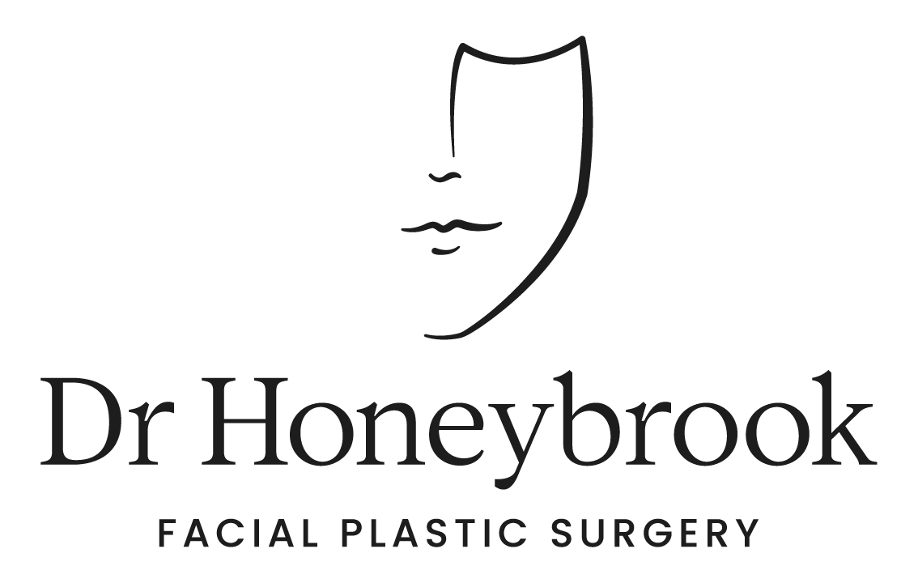

Brisbane Office
- 07 3488 8118
- 51 Ballow St, Fortitude Valley QLD 4006
- info@valleyplasticsurgery.com.au

Sydney Office
- 1800 678 679
- 18 Transvaal Ave, Double Bay NSW 2028
- info@onecosmetic.com

INSTRUCTIONS FOR PATIENTS HAVING RHINOPLASTY/SEPTOPLASTY/NASAL SURGERY

The following information is only a pre-operative guide. Our clinic nurse will contact you to confirm instructions specific to your care.

Videos

Pre-Operative Information
- Rhinoplasty: https://www.youtube.com/watch?v=UhSIIEIOM9c&t=2s

- Revision Rhinoplasty: https://www.youtube.com/watch?v=3hMAcPJymgg

Post-Operative Information
- Nasal Exercises: https://www.youtube.com/watch?v=9HlAeu8S0a8

- Nasal Splints: https://www.youtube.com/watch?v=RmE4pNq4_xU

- Nasal Taping: https://www.youtube.com/watch?v=g4tV331SSZ0&t=12s

Food/Drink

No food or drink should be taken six hours prior to surgery. Regular medications should be taken in the morning with a sip of water. Any preoperative medications that you have been told to take prior to your surgery should be taken according to office instructions.

Refrain from eating salty foods a day or two before surgery and for a few days after surgery to help reduce post-surgical swelling. Always maintain a high-water intake to keep your body well hydrated.

Supplements

Aspirin, aspirin-containing medications, aspirin-like medications, and ALL vitamins and herbs (e.g. herbal supplements such as fish oil, cod liver oil, garlic tablets, turmeric, curcumin) should not be taken for two weeks prior to surgery. Some herbal substances may lead to more bleeding in the area of the surgery that may in turn increase postoperative swelling. You may resume these herbal medications 3 weeks after surgery. Prior to surgery you can take additional protein, vitamin C and Zinc to aid in healing however this can be stopped once you undergo surgery.

Dr Honeybrook does recommend you take arnica montana and bromelain tablets for bruising and swelling after your surgery to aid in healing.

Smoking

Some chemicals in cigarette smoke interfere with skin circulation and can delay wound healing. This can result in wound breakdown and permanent scarring. Dr Honeybrook’s smoking policy is for patients to stop smoking 6 weeks pre and post-surgery to allow for optimum healing. Dr Honeybrook will not perform your surgery if you have not stopped smoking. This includes cigarettes, marijuana, nicotine patches and gum. We also prefer that no recreational drug use occurs during this period of time as well.

Pain Relief

Pain relief medication will be prescribed to assist with discomfort, take as required. You may experience constipation. If necessary, use Coloxyl and Senna in combination with the pain medication to reduce constipation.

Prior to Surgery

On the evening prior to surgery or on the day of surgery, please shower and shampoo your hair. No cosmetic products, makeup or jewellery should be worn on the day of your surgery. Please remove all nail polish/varnish. If you have shellac nails you must remove at least one to allow your oxygen levels to be monitored during surgery. If you have a moustache or beard, you will need shave this as this can be a potential source of infection and can make the surgery more challenging particularly if you are undergoing a face or neck lift.

To facilitate ease of dressing with minimal discomfort and so as not to disturb your dressing or sutures following surgery, wear a loose-fitting blouse or button-up shirt as opposed to a pull-over shirt for the first few days.

Two weeks prior to and four weeks post-surgery you cannot have any dental work performed.

Post Surgery

Following surgery, keep your head slightly elevated and apply cold compresses to your nose and eyes. This will help reduce postoperative bruising and swelling. A cold pack placed over a dry face cloth on your eyes and nose is effective. Cold compresses are useful for the first 48 hours after surgery.

If Dr Honeybrook has recommended you use arnica montana and/or bromelain, take as directed. You will be supplied with a separate sheet/s explaining the use of these supplements.

If you have silicone nasal splints inside the nose, the doctor or his nursing staff will usually remove these at the first post operative appointment. If you have sutures, these will also be removed at the first post op appointment. An external splint is often place on the outside of the nose and this will be removed at the first post operative appointment. If the external splint starts to fall off prior to the first appointment, this is okay, it does not need to be replaced.

Do not blow your nose heavily following removal 2 weeks following surgery. If you do, serious nosebleed may occur. Crusting in the nostril may be relieved by using a Neilmed of Flo sinus rinse saline irrigation bottle. You can also inhale moist steam through your nose. This will loosen nasal secretions so that you can gently blow your nose to clear it.

Refrain from bending or stooping to lift heavy objects for two weeks following surgery. When you bend over, your head is in a dependent position and blood rushes to your face and nose. This will increase swelling and pain and may cause a nosebleed. Strenuous exercising, such as aerobics, swimming, or jogging should be avoided for six weeks.

The nasal splint and any sutures that require removal are often removed within the first week of surgery. The nose will be swollen following removal of the splint. Do not be alarmed if the swelling actually worsens in the first few days after the splint is removed. This is normal. The swelling and bruising around the eyes will begin to settle within the first two weeks. Refrain from wearing eyeglasses that sit on the ridge until the swelling and discomfort on your nose has subsided. Swelling of the nose subsides very gradually, and may be present for months. Generally, swelling takes 12 months to fully resolve if this is your first rhinoplasty. If you are having a revision rhinoplasty performed, swelling can take up to 18 months to fully resolve. Bruising is very common in the early post operative period, and usually resolves in 1-2 weeks. The eventual appearance of the nose may not be apparent in some situations for up to 12-18 months.

NASAL EXERCISES

At the first post operative appointment, Dr Honeybrook will explain how to perform nasal exercises to reduce swelling after surgery. This involves placing the index finger on the bridge of the nose until slightly uncomfortable for 10 seconds, 10x a day. The next exercise involves taking both index fingers and placing on the sides of the nose until slightly uncomfortable for 10 seconds, 10x a day.

PROBLEMS TO REPORT

You should notify the office or the emergency department if any of the following occurs: chills or fever (temperature above 38°C), nausea and vomiting that does not appear to be resolving, redness, swelling, foul-smelling discharge/odor, excessive bleeding from the incision areas or if the incision has opened.

RHINOPLASTY/NASAL SURGERY EXPECTATIONS

Dr Honeybrook strives to achieve the agreed aesthetic and functional goals you have discussed in consultation. These functional and aesthetic goals are limited by your underlying nasal anatomy. Despite best efforts, there are instances where patients may not be completely satisfied with the outcome. Dr Honeybrook cannot guarantee results – nobody can. He can’t guarantee how you will FEEL about your result, and if you will like it as much as you expected, nor can he promise perfection. He cannot guarantee how long your result will last, and results will vary person to person, and from one treatment to another. It is important to have realistic expectations about your surgery.

Rhinoplasty is complex surgery, and your outcome will depend upon on your starting anatomy, surgical execution, and your healing after surgery. There will be limitations to what can be achieved, and complications may occur. The unavoidable risks of any surgical treatment will include under-correction, over-correction, dissatisfaction, disappointment, and persistent imperfections. In some circumstances, secondary (revision) treatments may be necessary and yes, these will attract additional fees.

Important things to keep in mind:
- Your nose will never be perfect after rhinoplasty.
- A nicer and better breathing nose will harmonize the face, but it won’t necessarily change your life.
- Swelling and internal scarring may persist for a long time (even beyond 1 year)
- Asymmetries, irregularities, and imperfections may be present, even if they were not there beforehand.
- A crooked nose can be made straighter, but it will not be 100% straight or perfectly aligned to the rest of the face.
- Tip position may move or drop over time.
- Breathing difficulties may occur.
- Regular follow up is important, so that we can work together to optimise the healing process.

Please proceed with surgery ONLY if you understand, feel comfortable, and can accept the above facts. Rhinoplasty can be an emotional transformative journey and it is important to understand the above information before proceeding.

If you have any questions, Dr Honeybrook is more than happy to consult with you again to discuss any concerns you have.

FOLLOW UP CARE

Your follow up visit is usually 1 to 2 weeks after surgery. If you do not already have a post-surgery follow up appointment, please call the office number listed above where you were originally seen. If you have any questions or concerns prior to your scheduled appointment, please call the office and speak with one of our nursing team during business hours (8:30AM – 4:30PM).

In case of a LIFE THREATENING emergency please call 000.

Any other information regarding this procedure or any other surgical procedure can be found at www.drhoneybrook.com.au.

