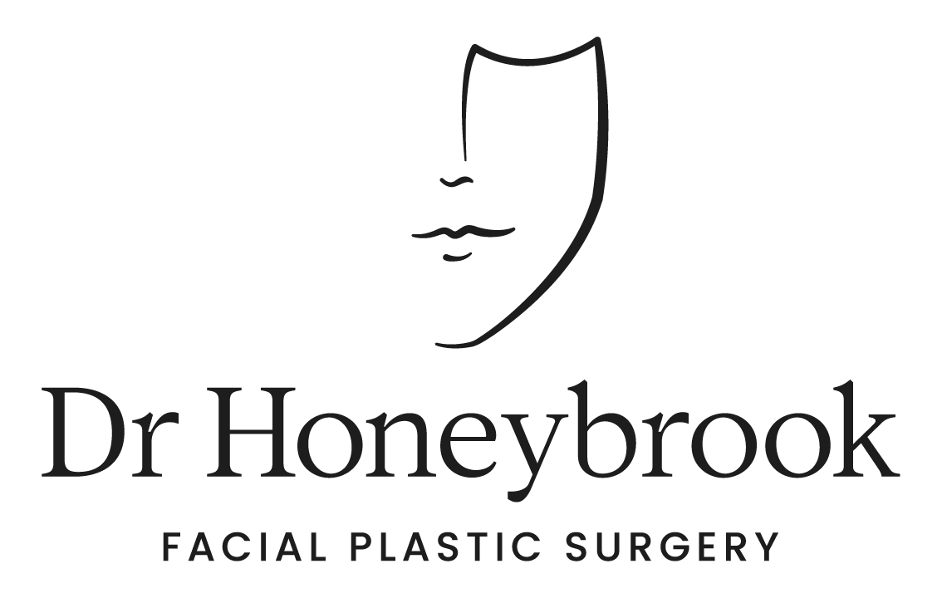

Brisbane Office
- 07 3488 8118
- 51 Ballow St, Fortitude Valley QLD 4006
- info@valleyplasticsurgery.com.au

Sydney Office
- 1800 678 679
- 18 Transvaal Ave, Double Bay NSW 2028
- info@onecosmetic.com

SURGICAL CONSENT – FACIAL AESTHETIC SURGERY

READ INFORMATION CAREFULLY BEFORE SIGNING
PATIENT CONSENT TO MEDICAL TREATMENT OR SURGICAL PROCEDURE AND ACKNOWLEDGEMENT OF RECEIPT OF MEDICAL INFORMATION

TO THE PATIENT: You have been advised that you may benefit from a surgical procedure. You have the right, as a patient, to be informed about your condition and the recommended surgical procedure so that you may make an informed decision whether or not to undergo the procedure after knowing the risks and potential complications involved.
In keeping with Australian law, you are being asked to sign a confirmation that we have discussed these matters. We have already discussed with you the common risks and potential complications. We wish to inform you as completely as possible. Please read the form carefully. Ask about anything you do not understand, and we will be pleased to explain this to you further.

Patient Name:
Treatment/Procedure:
- Description of the treatment/procedure:
      - Deep plane facelift with platysmaplasty (neck lift)
      - Browlift
      - Facial fat grafting
      - Full face CO2 resurfacing
      - Subnasal lip lift
      - Chin implant
      - Ear lobe reduction
  - The above listed surgical procedures are aimed to restore a youthful appearance to the face
- Surgical indications: Aesthetic facial deformities, aging facial appearance, facial photoaging
- Purpose: To change the appearance and/or function of the face

Material Risks of the Surgical Procedure
General Risks:
All surgical treatment involves some risk. General operative and anaesthetic risks include, but are not limited to, the following:
- A sore throat/breathing difficulties due to the general aesthetic or the endotracheal tube, which can cause swelling, noisy breathing or discomfort
- Short-term nausea following general anaesthesia
- Wound infection, which may result in treatment with antibiotics or further treatment/surgery. This is more likely in a smoker or a person with diabetes.
- Heavy bleeding from the wound, which may result in the need for further treatment/surgery
- Wound discharge
- Poor or slow healing of the skin; wound breakdown; skin necrosis
- Wound dehiscence (wound ruptures along the surgical incision)
- Bruising and swelling. This will start to subside in one to two weeks but can take up to several months to settle down
- Abscess/Haematoma/Seroma/Oedema
- Pain and discomfort
- Allergic reaction to sutures, dressing, antiseptic solutions
- Altered or loss of sensation in and around the treated area, which may persist for some months, numbness may be permanent
- Adverse scarring
- Revisionary surgery
- Psychological impact of change in appearance
- Unsatisfactory cosmetic appearance
- Acute medical event: Heart or lung complications (e.g., heart attack, stroke, chest infections)
- Death
- DVT/PE

Specific Risks:
There are also risks specific to this procedure. Listed below are those risks associated with this procedure that we believe a reasonable person in your (the patient’s) position would likely consider significant when deciding whether to have or forego the proposed therapy. Please ask your surgeon if you would like additional information regarding the nature or consequences of these risks, their likelihood of occurrence, or other associated risks that you might consider significant but may not be listed below.
Face/Neck
- Asymmetry
- Haematoma/Seroma – collection of blood or fluid under the skin surface
- Facial Nerve Injury - Nerve damage which may cause temporary or permanent changes to facial expression, including smile
- Loss of sensation to the ear
- Vascular injury
- Parotid/Duct Injury – Resulting in leakage/collection of saliva (sialocele)
- Skin death
- Scarring
- Deformity of the ear lobe
- Hair thinning/loss or change to hairline position
- Skin Pigmentary Changes/Temporary or permanent colour/texture changes to skin such as mottling
- Contour Deformities - After healing is complete, neck skin may look puckered, wavy or rippled
  - Cobra deformity: Hollow depression above the hyoid with overly aggressive liposculpting of submentum and neck, inadequate platysmaplasty
- The shape of the underlying structures (such as lymph nodes and the platysma) may be visible after liposuction
- Depression/Mental health issues

Brow:
- Asymmetry
- Rarely, permanent injury to the nerves that control eyebrow movement
- Hairline position changes
- Hair loss may occur near the treated area
- Drill holes through the skull bone – may cause CSF leak

Additional risks (if any) particular to the patient because of a complicating medical condition are:
_____________________________________________________________

ACKNOWLEDGEMENT - AUTHORIZATION AND CONSENT

- No Guarantees: All information provided, in particular, all estimates made as to the likelihood of occurrence of risks of this or alternate procedures or as to prospects of success, are made in the best professional judgement of the surgeon. The possibility and nature of complications cannot always be accurately anticipated and, therefore, there it cannot be guaranteed, either expressed or implied, as to the success or result of the surgical procedure.
- Additional Information: Nothing has been said to me, no information has been given to me, and I have not relied upon any information that is inconsistent with the information set forth in the document.
- Particular Concerns: I have had an opportunity to disclose to and discuss with the surgeon providing such information, those risks or other potential consequences of the surgical procedure that are of particular concern to me.
- Questions: I have had an opportunity to ask, and I have asked, any questions I may have about the information in this document and any other questions I have about the proposed treatment or procedure, and all such questions were answered in a satisfactory manner.
- Authorised Surgeon: The surgeon authorised to administer or perform the surgical procedure listed in this document is Dr Adam Honeybrook MBBS, FACS, FRACS
- Physician Certification: I hereby certify that I have provided and explained the information set forth herein concerning the surgical procedure to the best of my knowledge and ability.

__________________________ _______________
Signature of Surgeon Date

Consent
- Consent: I hereby authorise and direct the designated authorised surgeon, together with associates and assistant/s of his choice, to administer or perform the surgical procedure described in this consent form, including any additional procedures or services as may be deemed necessary or reasonable, including the administration of any general or regional anaesthetic agent, radiological services, laboratory services, and the disposal of any tissue removed during a surgical procedure, and I hereby consent thereto.
- I have read and understand all information set forth in this document. The authorisation for, and consent to, the above listed surgical procedure shall remain valid until revoked.
- I understand the importance of following pre-treatment and post treatment instructions and failure to comply with these instructions may increase the possibility of complications or result in a poorer outcome
- I understand that ancillary procedures may be required and in the event that ancillary procedures are required, it could result in additional fees
- I acknowledge that I have had the opportunity to ask any questions about the contemplated surgical procedure described in this consent form, including risks and alternatives, and acknowledge that my questions have been answered to my satisfaction.

__________________________ _______________
Patient or Person Authorised to Consent Date

__________________________
Signature of Patient

If signed by someone other than the patient, state the reason and relationship:

_____________________________________________________________

