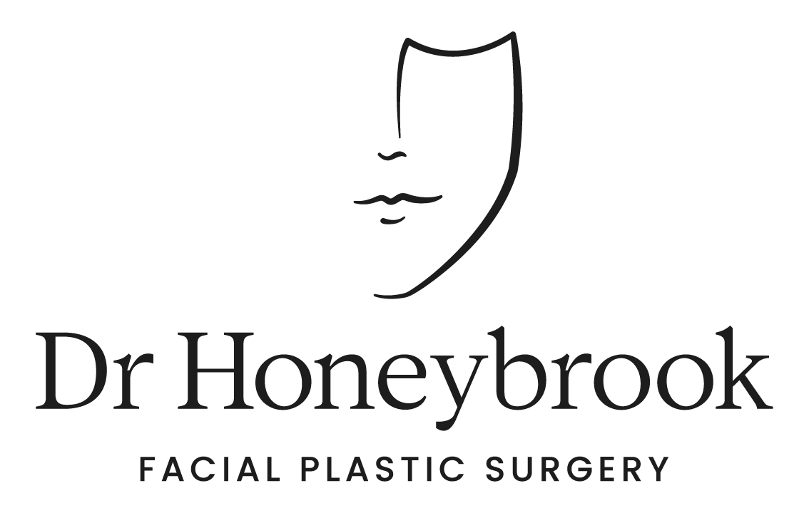

Brisbane Office
- 07 3488 8118
- 51 Ballow St, Fortitude Valley QLD 4006
- info@valleyplasticsurgery.com.au

Sydney Office
- 1800 678 679
- 18 Transvaal Ave, Double Bay NSW 2028
- info@onecosmetic.com

INSTRUCTIONS FOR PATIENTS HAVING BUCCAL FAT REMOVAL SURGERY

The following information is only a pre-operative guide. Our clinic nurse will contact you to confirm instructions specific to your care.

Food/Drink

No food or drink should be taken six hours prior to surgery. Regular medications should be taken in the morning with a sip of water. Any preoperative medications that you have been told to take prior to your surgery should be taken according to office instructions.

Refrain from eating salty foods a day or two before surgery and for a few days after surgery to help reduce post-surgical swelling. Always maintain a high-water intake to keep your body well hydrated.

Supplements

Aspirin, aspirin-containing medications, aspirin-like medications, and ALL vitamins and herbs (e.g. herbal supplements such as fish oil, cod liver oil, garlic tablets, turmeric, curcumin) should not be taken for two weeks prior to surgery. Some herbal substances may lead to more bleeding in the area of the surgery that may in turn increase postoperative swelling. You may resume these herbal medications 3 weeks after surgery. Prior to surgery you can take additional protein, vitamin C and Zinc to aid in healing however this can be stopped once you undergo surgery.

Dr Honeybrook does recommend you take arnica montana and bromelain tablets for bruising and swelling after your surgery to aid in healing.

Smoking

Some chemicals in cigarette smoke interfere with skin circulation and can delay wound healing. This can result in wound breakdown and permanent scarring. Dr Honeybrook’s smoking policy is for patients to stop smoking 6 weeks pre and post surgery to allow for optimum healing. Dr Honeybrook will not perform your surgery if you have not stopped smoking. This includes cigarettes, marijuana, nicotine patches and gum. We also prefer that no recreational drug use occurs during this period of time as well.

Pain Relief

Pain relief medication will be prescribed to assist with discomfort, take as required. You may experience constipation. If necessary, use Coloxyl and Senna in combination with the pain medication to reduce constipation.

Prior to Surgery

On the evening prior to surgery or on the day of surgery, please shower and shampoo your hair. No cosmetic products, makeup or jewellery should be worn on the day of your surgery. Please remove all nail polish/varnish. If you have shellac nails you must remove at least one to allow your oxygen levels to be monitored during surgery. If you have a moustache or beard, you will need shave this as this can be a potential source of infection and can make the surgery more challenging particularly if you are undergoing a face or neck lift.

To facilitate ease of dressing with minimal discomfort and so as not to disturb your dressing or sutures following surgery, wear a loose fitting blouse or button-up shirt as opposed to a pull-over shirt for the first few days.

Two weeks prior to and four weeks post surgery you cannot have any dental work performed.
Post Surgery

Your lower face will be significantly swollen after the procedure. This is normal. Often there is compensatory swelling that fills the buccal space after the fat is removed. It is common for the swelling and mild bruising to occur and peak 2-3 days following surgery.

Dissolvable sutures will be used for all intraoral wound closures. These sutures will usually take 2-3 weeks to fall out. For two weeks, it is vital that you perform mouth washes FOUR times a day, and especially after meals. Any mouthwash that can be purchased over the counter will be suitable.

You will also be provided with a prescription for an antibiotic called Bactrim which you will take twice a day for 7 days.

Starting on the days after surgery, shower at least once a day, shampooing your hair. Keep your head elevated at all times for the first week of recovery. We recommend sleeping on 2-3 pillows at night.

Refrain from bending or stooping to lift heavy objects for two weeks following surgery. When you bend over, your head is in a dependent position and blood rushes to your face and nose. This will increase swelling and pain and may cause a nosebleed. Strenuous exercising, such as aerobics, swimming, or jogging should be avoided for six weeks.

PROBLEMS TO REPORT
- Signs of infection:
  - Increasing redness
  - Increasing pain
  - Fever
  - Discharge of pus from the wound
- Increasing swelling
- Prolonged or increasing volume of bleeding
- Nausea or vomiting that is not settling
- Chest pain and /or shortness of breath
- Pain in your calves
FOLLOW UP CARE

Your follow up visit is usually 1 to 2 weeks after surgery. If you do not already have a post-surgery follow up appointment, please call the office number listed above where you were originally seen. If you have any questions or concerns prior to your scheduled appointment, please call the office and speak with one of our nursing team during business hours (8:30AM – 4:30PM).

In case of a LIFE THREATENING emergency please call 000.

Any other information regarding this procedure or any other surgical procedure can be found at www.drhoneybrook.com.au.

